J2EE, Exam-5, Quiz

1. What is the function of wait () and notify ()?

Ans:-

**wait()-**It tells the calling thread to give up the lock and go to sleep until some other thread enters the same monitor and calls notify().

**notify()-**It wakes up one single thread that called wait() on the same object. It should be noted that calling notify() does not actually give up a lock on a resource.

1. What is deadlock?

Ans: Deadlock in java is a part of multithreading. Deadlock can occur in a situation when a thread is waiting for an object lock, that is acquired by another thread and second thread is waiting for an object lock that is acquired by first thread. Since, both threads are waiting for each other to release the lock, the condition is called deadlock.

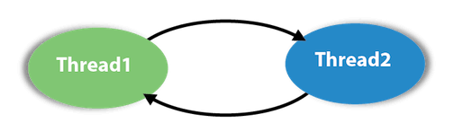

1. What is stream? How you classify them?

**Ans.** A stream is a sequence of objects that supports various methods which can be pipelined to produce the desired result.

Java encapsulates Stream under **java.io** package. Java defines two types of streams. They are,

1. **Byte Stream :** It provides a convenient means for handling input and output of byte.
2. **Character Stream :** It provides a convenient means for handling input and output of characters. Character stream uses Unicode and therefore can be internationalized.

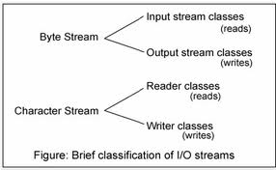

1. What is collection? Write the type of collection.

Collections are objects that group other objects according to a conceptual scheme. For example, a card deck is a collection of cards; a dictionary is a collection of words. Collection is another term for data structures. They are used to store, manipulate and retrieve aggregate data. We will distinguish collections in the following ways:

• Linear   (arrays, lists, stacks, queues)

• Hierarchical   (various kinds of trees)

• Graphs

In a **linear** collection each element (except the first and last) has a unique predecessor and successor.

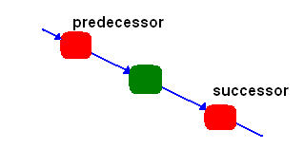

In a **hierarchical** collection, each element (except one, called the root) has a unique predecessor and zero or more successors. In the next picture, the root is in red

1. 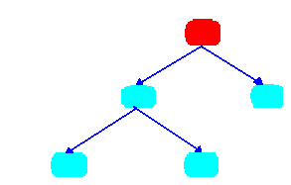

In a **graph**, each element has many predecessors and successors.

1. 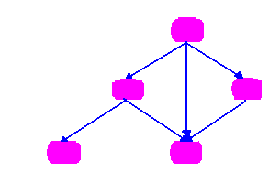

Java collections (called the Java Collections Framework) is a set of interfaces and generified classes found in the package *java.util*. They are defined through three major interfaces: List, Set and Map:

|  |  |
| --- | --- |
| **Interfaces** | **Implementations** |
| List | LinkedList, ArrayList |
| Set | HashSet, TreeSet |
| Map | HashMap, TreeMap, Hashtable |

1. What is event handler?

**Event** Handling is the mechanism that controls the **event** and decides what should happen if an **event** occurs. This mechanism have the code which is known as **event handler** that is executed when an **event** occurs. **Java** Uses the Delegation **Event** Model to handle the **events**. ... **Java** provide as with classes for source object.

1. What is the advantages of adapter class? Write down three adapter class.

**Java adapter classes** provide the default implementation of listener interfaces. If you inherit the **adapter class**, you will not be forced to provide the implementation of all the methods of listener interfaces. So it saves code. The **adapter classes** are found in **java**.

**Advantages** of an **Adapter Class**: If a **class** extends an **Adapter Class**, we can override some methods which is needed; It can simplify the creation of the Event handlers in certain situations; It provides an empty implementation of all methods in an EventListener Methods.

1. What is the feature of Swing?

**1. Platform Independent:** It is platform independent, the swing components that are used to build the program are not platform specific. It can be used at any platform and anywhere.

**2. Lightweight:** Swing components are lightweight which helps in creating the UI lighter. Swings component allows it to plug into the operating system user interface framework that includes the mappings for screens or device and other user interactions like key press and mouse movements.

**3. Plugging:** It has a powerful component that can be extended to provide the support for the user interface that helps in good look and feel to the application. It refers to the highly modular-based architecture that allows it to plug into other customized implementations and framework for user interfaces. Its components are imported through a package called java.swing.

**4. Manageable:** It is easy to manage and configure. Its mechanism and composition pattern allows changing the settings at run time as well. The uniform changes can be provided to the user interface without doing any changes to application code.

**5. MVC:** They mainly follows the concept of MVC that is [Model View Controller](https://www.educba.com/what-is-mvc/). With the help of this, we can do the changes in one component without impacting or touching other components. It is known as loosely coupled architecture as well.

**6. Customizable:** Swing controls can be easily customized. It can be changed and the visual appearance of the swing component application is independent of its internal representation.

1. What is layout manager?

The LayoutManagers are used to arrange components in a particular manner. LayoutManager is an interface that is implemented by all the classes of layout managers. There are following classes that represents the layout managers:

1. java.awt.BorderLayout
2. java.awt.FlowLayout
3. java.awt.GridLayout
4. java.awt.CardLayout
5. java.awt.GridBagLayout
6. javax.swing.BoxLayout
7. javax.swing.GroupLayout
8. javax.swing.ScrollPaneLayout
9. javax.swing.SpringLayout etc.
10. What are the two ways of creating thread?

**There are two ways to create a thread:**

* Extends **Thread** class. **Create** a **thread** by a new class that extends **Thread** class and **create** an instance of that class. ...
* Implementing the Runnable Interface. The easiest **way to create** a **thread** is **to create** a class that implements the runnable interface.

10.Write down the thread states diagram.

<<https://javaconceptoftheday.com/thread-life-cycle-thread-states-java/>>

